TABLE OF CONTENTS

|  |  |
| --- | --- |
| **Acknowledgement** | **i** |
| **Candidate declaration** | **ii** |
| **Supervisor declaration** | **iii iii** |
| **List of figures** | **iv** |
| **Pert chart** | **v** |
| |  |  | | --- | --- | |  | Page No.ber | | CHAPTER1: INTRODUCTION |  | | 1.1 Need of the Study | 2 | | 1.2 Scope of the Study |  | | 1.3 Objective of the Study |  | | CHAPTER 2: IMPLEMENTATION OF PROPOSED METHOD/MODEL |  | | 2.1 Topology | 11 | | 2.2 Cables Used |  | | 2.3 Hardware Used |  | | 2.4 Command line Interface(CLI) |  | | 2.5 Services Used |  | | 2.6 Configuration |  | | CHAPTER 3: EXPERIMENTAL RESULTS (Outputs) | 64 | | CHAPTER 4: CONCLUSIONS AND FUTURE SCOPE | 65 | |  |
|  |  |
|  |  |

CHAPTER 1: INTRODUCTION

Computer Networks a computer network is interconnection of various computer systems located at different places. In computer network two or more computers are linked together with a medium and data communication devices for the purpose of communication data and sharing resources. The computer that provides resources to other computers on a network is known as server. In the network the individual computers, which access shared network resources, are known as nodes.

Types of Networks

There are many different types of networks. However, from an end user's point of view there are three basic types:

* Local Area Network (LAN)
* Metropolitan Area Network (WAN)
* Wide Area Network (WAN)

Local-Area Network (LAN) The computers are geographically close together (that is, in the same room or building).

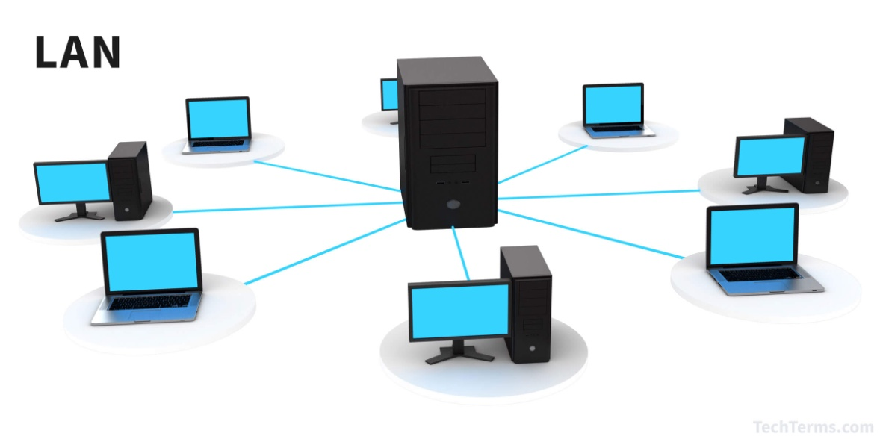

FIG 1.1 Local Area Network

**METROPOLITAN AREA NETWORK MAN**

A Metropolitan Area Network (MAN) is a computer network in which two or more computers or communicating devices or networks which are geographically separated but in same metropolitan city and are connected to each other are said to be connected on MAN.

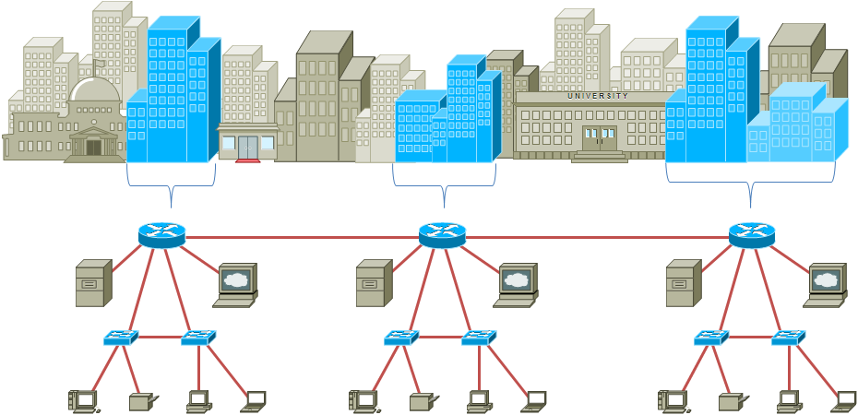

FIG 1.2Metropolitan Area Network

**Wide-Area Network (WAN)**

A Wide Area Network (WAN) is a network that covers a broad area (i.e., any telecommunications network that links across metropolitan, regional, or national boundaries) using private or public network transports. WAN is a computer network spanning regions, countries, or even the world.

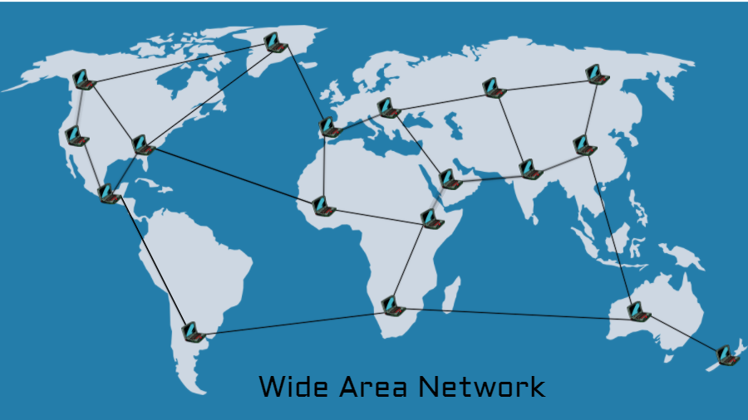

FIG 1.3 Wide Area Network

Network Topologies the geometric arrangement of computer system is termed as a topology. Common topologies include Bus, Star, Mesh, Ring and Hybrid.

**Bus Topology**

In Bus Networks the ends are not connected. All communications are carried on a common cable or bus and are available to each device on the network.

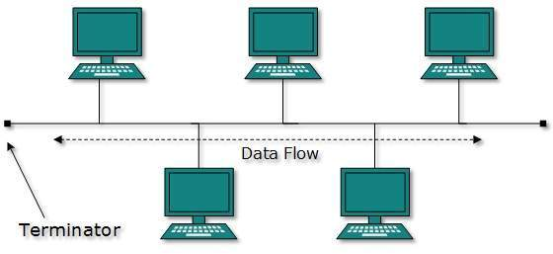

FIG 1.4 Bus Topology

Access and control of bus networks are typically maintained by a method called contention, whereby if a line is unused, a terminal or device can transmit its message at will, but if two or more terminals initiate messages simultaneously, they must stop and transmit again at different intervals.

**Star Topology**

The Star Network is frequently used to connect one or more small computers or peripheral devices to a large host computer or CPU. Many organizations use the star network or a variation of it in a time-sharing system, in which several users are able to share a central processor.

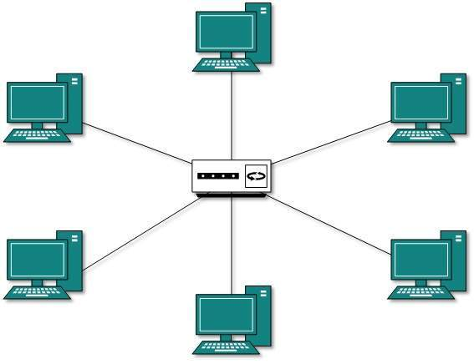

FIG 1.5 Star Topology

In a time-sharing setup, each terminal receives a fixed amount of the CPU's time, called a time slice. If you are sitting at a terminal and cannot complete your task during the time slice, the computer will come back to you to allow you to do so. If the user of one microcomputer wants to send a document or message to a user at another computer, the message is routed through the central communications controller commonly called as HUB. Another common use of the star network is the feasibility of connecting several microcomputers to a mainframe computer that allows access to an organization's database. Access and control of star network typically is maintained by a polling system. Polling means that the central computer or communications controller "polls" or asks each device in the network if it has a message to send and then allows each in turn to transmit data.

**Mesh Topology**

Or Mesh network, mesh is a network topology in which devices are connected with many redundant interconnections between network nodes. In a true mesh topology every node has a connection to every other node in the network.

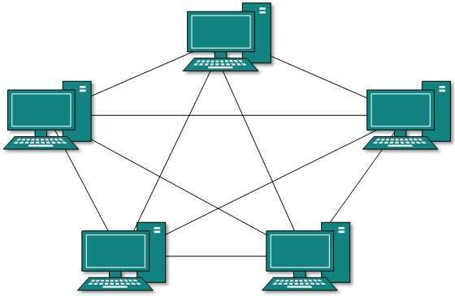

FIG 1.6 Mesh Topology

**Ring Topology**

The Ring Network is a Local Area Network (LAN) whose topology is a ring - can be as simple as a circle or point-to-point connections of computers at dispersed locations, with no central host computer or communications controller. That is, all of the nodes are connected in a closed loop. Messages travel around the ring, with each node reading those messages addressed to it. One of the advantages of ring networks is that they can span larger distance than other types of networks, such as bus networks, because each node regenerates messages as they pass through it.

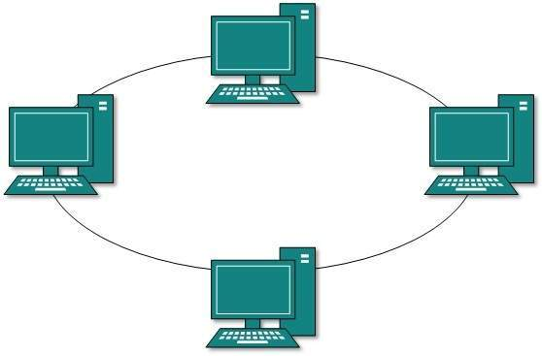

FIG 1.6 Ring Topology

Access and control of ring networks are typically maintained by a "token-passing" system. IBM's Token-Ring network is thought by some observers to be a watershed event comparable to the development of the IBM PCV itself, because the Token-Ring network is designed to link all types of computers together, including not only personal computers but also possible mini computes and mainframes.

**Hybrid Topology**

The combination of two or more of the above mentioned topologies is called a Hybrid Network. For example the below shown network is the combination of Bus, Star and Ring topology.

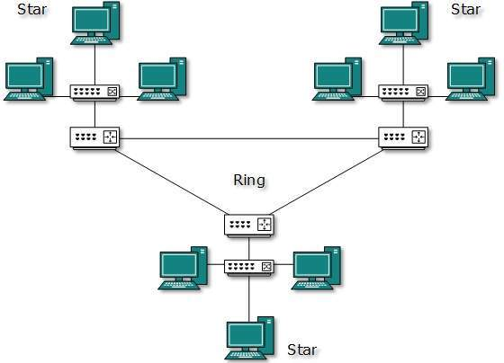

FIG 1.7 Hybrid Topology

**1.1 NEED OF STUDY**

* **Get connected to the most connected people**

There is a worldwide community of people just like you. More than 4.75 million students in 165 countries have participated in Cisco Networking Academy courses since 1997. That’s a lot of friends to find and connect with on LinkedIn or the Cisco Networking Academy Facebook page, which has over 530,000 student and instructor members who use it to stay in touch, ask questions, and learn about new learning opportunities. Most academies have their own Facebook sites and many have LinkedIn communities.

* **Every workplace needs a few friendly geeks**

Networking skills give you an edge and an opportunity to make a career in almost any sector you can imagine: financial services, education, transportation, manufacturing, oil and gas, mining and minerals, technology, government, hospitality, health care, retail... you name it. If you have an interest in a particular field, technology is probably part of it. For example, health care clinicians study networking technology to better understand how to use it in their practice. At Effat University in Saudi Arabia, women have dramatically expanded their career opportunities by adding networking to their skills set. Veteran Matt He fler became a virtual systems engineer with several job offers after his networking studies. Whether you see yourself with your own business, as part of a small company or inside a global corporation, networking basics open the door to help advance your career.

Computer networks help users on the network to share the resources and in communication. Can you imagine a world now without emails, online newspapers, blogs, chat and the other services offered by the internet?

* **File sharing**: Networking of computers helps the network users to share data files.
* **Hardware sharing**: Users can share devices such as printers, scanners, CD-ROM drives, hard drives etc. Without computer networks, device sharing is not possible.
* **Application sharing**: Applications can be shared over the network, and this allows to implement client/server applications
* **User communication**: Networks allow users to communicate using e-mail, newsgroups, and video conferencing etc.
  1. **SCOPE OF STUDY**

Networking is evergreen, it is only going to get bigger and more complex.

But it is not very easy to enter as a fresher, but if your're passionate about it then you have to study and practice hard. Unlike software programming, where the job is more confined to simply coding this area demands hands-on/practical knowledge on multiple networking hardware, platforms, network protocols and more importantly problem solving skills. If you have the proper skills, you'll be on demand.

"The network of the future will seamlessly interconnect a tremendous number of terminals, devices, machines, and smart objects at the edge—where the users are—with the enormous processing power available in the cloud. Cloud computing, SDNs, and NFV are  different facets of the same worldwide industry transformation toward the ‘IT-ization’ of any process.”( December 8, 2014)

* 1. **OBJECTIVE OF STUDY**
* Understand state-of-the-art in network
* protocols, architectures, and applications
  + Process of networking research
  + Constraints and thought processes for
* networking research
  + Problem Formulation—Approach—Analysis—
* Results
  + Different from undergraduate networking
* (EECS 122)
  + i.e., training network programmers vs. training
* network *researchers*

CHAPTER 2: IMPLEMENTATION OF PROPOSED METHOD

**2.1 SYSTEM REQUIREMENT**

**Simulation Software**

Simulation is the imitation of the operation of a real-world process or system over time.[1] The act of simulating something first requires that a model be developed; this model represents the key characteristics, behaviors and functions of the selected physical or abstract system or process. The model represents the system itself, whereas the simulation represents the operation of the system over time.

**Packet Tracer**

It is a cross-platform visual simulation tool designed by Cisco Systems that allows users to create network topologies and imitate modern computer networks. The software allows users to simulate the configuration of Cisco routers and switches using a simulated command line interface. Packet Tracer makes use of a drag and drop user interface, allowing users to add and remove simulated network devices as they see fit. The software is mainly focused towards Certified Cisco Network Associate Academy students as an educational tool for helping them learn fundamental CCNA concepts. Previously students they had enrolled in a CCNA Academy program could freely download and use the tool free of charge for educational use.[1] Since August 2017 with version 7.1 is free to everyone.

**2.2 CABLES USED**

**Twisted-pair**

This wire comes in several ―standards.‖ Unshielded twisted pair (UTP) Category 3 wire (also called 10BaseT) is often used for your phone lines, and UTP Category 5 (also called 10Base2) wire is the current networking standards. Coaxial resembles round cable TV wiring.

**Fiber-optic**

Usually reserved for connections between backbone‖ devices in larger networks, though in some very demanding environments, highly fault resistant cable is used to connect desktop workstations to the network and to link adjacent buildings.

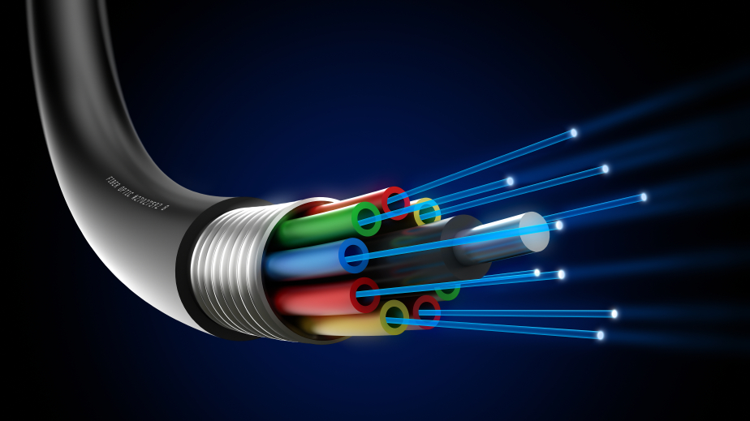

FIG 2.1 Fiber Optic Cable

Fiber-optic cable is the most reliable wiring but also the most expensive. For instance, Ethernet can useUTP Category 3 wiring. However, Fast Ethernet requires at least the higher-grade UTP Category 5 wiring. As a result, all new wiring installations should be Category 5.

**Coaxial**

Coaxial cable or coax is a type of cable that has an inner conductor surrounded by a tubular insulating layer, surrounded by a tubular conducting shield. Many coaxial cables also have an insulating outersheath or jacket. The term coaxial comes from the inner conductor and the outer shield sharing a geometric axis.

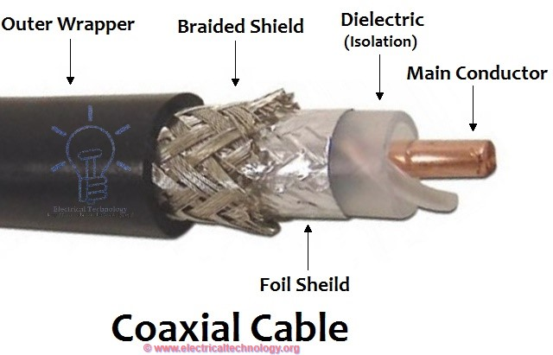

FIG 2.2 Coaxial Cable

**SERIAL CABLE**

A serial cable is a cable used to transfer information between two devices using a serial communication protocol. The form of connectors depends on the particular serial port used. A cable wired for connecting two DTEs directly is known as a null modem cable.

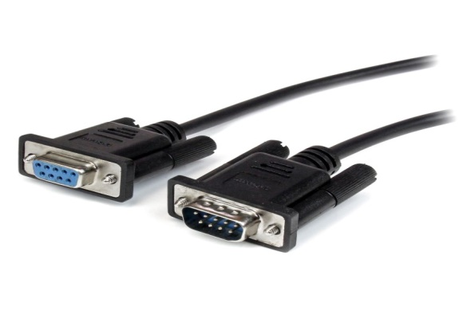

FIG 2.3 Serial Cable

**CROSS OVER CABLE**

A crossover cable connects two devices of the same type, for example DTE-DTE or DCE-DCE, usually connected asymmetrically (DTE-DCE), by a modified cable called a crosslink.[1] Such distinction of devices was introduced by IBM.

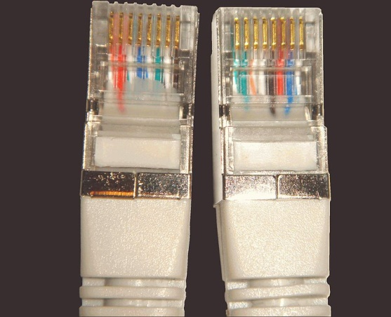

FIG 2.4 Cross Over Cable

**2.3HARDWARE USED**

**Gateway**

This device is placed at a network node and interfaces with another network that uses different protocols. It works on OSI layers 4 to 7.

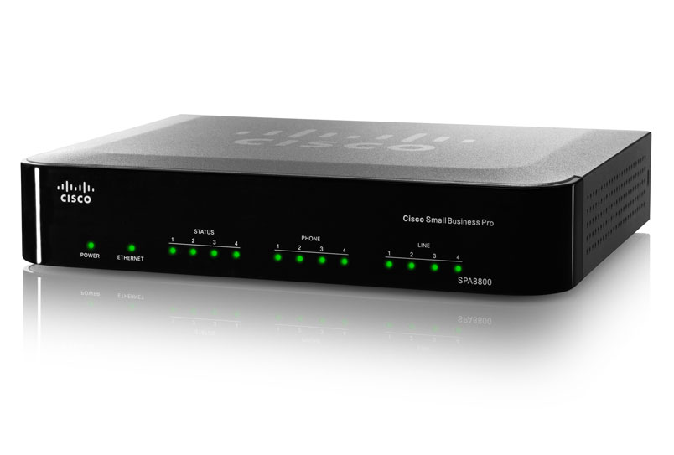

FIG 2.5 Gateway

**Bridge**

A device that connects multiple network segments along the data link layer. It works on OSI layer 2.

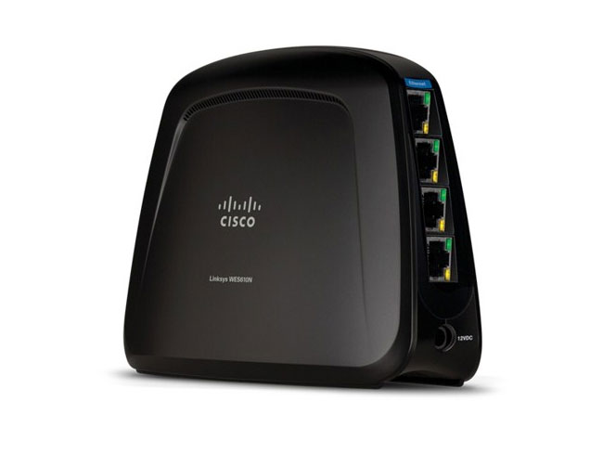

FIG 2.6 Bridge

**Repeater**

A device which amplifies or regenerates digital signals received while sending them from one part of a network into another. It works on OSI layer 1.

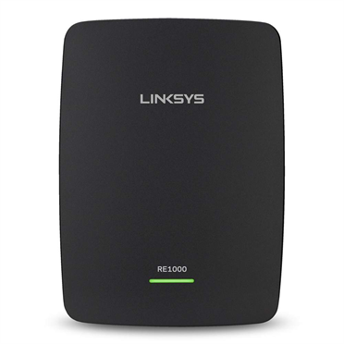

FIG 2.7 Repeater

**Hubs**

Hubs, or repeaters, are simple devices that interconnect groups of users. Hubs forward any data packets they receive over one port from one workstation—including e-mail, word processing documents, spread-sheets, graphics, or print requests—to all of their remaining ports. All users connected to a single hub or stack of connected hubs are in the same segment, sharing the hub’s bandwidth or data-carrying capacity.

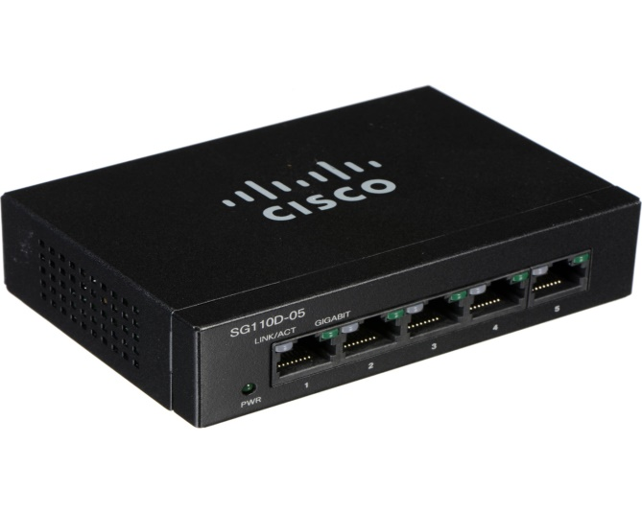

FIG 2.8 Hub

As more users are added to a segment, they compete for a finite amount of bandwidth devoted to that segment. : a device that connects multiple Ethernet segments, making them act as a single segment. When using a hub, every attached device shares the same broadcast domain and the same collision. Therefore, only one computer connected to the hub is able to transmit at a time. Depending on the network topology, the hub provides a basic level 1 OSI model connection among the network objects (workstations, servers, etc.). It provides bandwidth which is shared among all the objects, in contrast to switches, which provide  
Aconnection between individual nodes. It works on OSI layer 1.

**Switches**

Switches are smarter than hubs and offer more bandwidth. A switch forwards data packets only to the appropriate port for the intended recipient, based on information in each packet’s header. To insulate the transmission from the other ports, the switch establishes a temporary connection between the source and destination then terminates the connection when the conversation is done

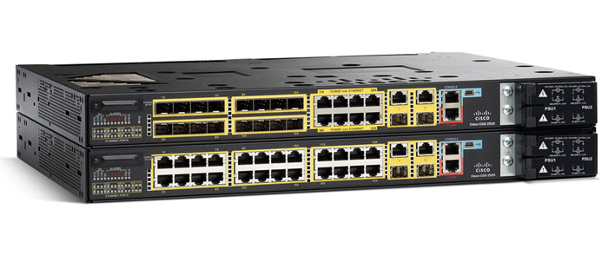

FIG 2.9 Cisco Switch

. As such, a switch can support multiple ―conversations‖ and move much more traffic through the network than a hub. A single eight-port Ethernet hub provides a total of 10 megabits per second (Mbps) of data- carrying capacity shared among all users on the hub. A ―full-duplex, eight-port Ethernet switch can support eight 10-Mbps conversations at once, for a total data-carrying capacity of 160 Mbps. ―Full-duplex‖ refers to simultaneous two-way communications, such as telephone communication. With half-duplex communications, data can move across the cable or transmission medium in just one direction at a time. : a device that allocates traffic from one network segment to certain lines (intended destination(s)) which connect the segment to another network segment. Unlike a hub, a switch splits the network traffic and sends it to different destinations rather than to all systems on the network. It works on OSI layer 2.

**Routers**

Compared to switches and bridges, routers are smarter still. Routers use a more complete packet ―address‖ to which router or workstation should receive each packet. Based on a network roadmap called a ―routing table,‖ routers can help ensure that packets are travelling the most efficient paths to their destinations. If a link between two routers goes down, the sending router can determine an alternate route to keep traffic moving. Routers also provide links between networks that speak different languages—or, in computer speak—networks that use different

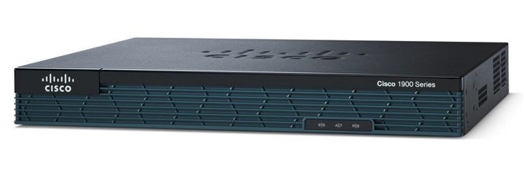

FIG 2.10 Cisco Router

―protocols.‖ Examples include IP (Internet Protocol), the IPX® (Internet Packet Exchange Protocol), and AppleTalk. Routers not only connect networks in a single location or set of buildings, but they provide interfaces— or ―sockets‖—for connecting to wide-area network (WAN) services. These WAN services, which are offered by telecommunications companies to connect geographically, dispersed networks. : a specialized network device that determines the next network point to which it can forward a data packet towards the ultimate destination of the packet. Unlike a gateway, it cannot interface different protocols. It works on OSI layer 3.

**2.4 Command Line Interface (CLI)**

Cisco IOS has three command modes, each with access to different command sets:

**User mode** - This is the first mode a user has access to after logging into the router. The user mode can be identified by the > prompt following the router name. This mode allows the user to execute only the basic commands, such as those that show the system's status. The system cannot be configured or restarted from this mode.

**Privileged mode** - This mode allows users to view the system configuration, restart the system, and enter configuration mode. It also allows all the commands that are available in user mode. Privileged mode can be identified by the # prompt following the router name. The user mode enable command tells IOS that the user wants to enter privileged mode. If an enable password or enable secret password has been set, the user needs to enter the correct password or secret to be granted access to privileged mode. An enable secret password uses stronger encryption when it is stored in the configuration and, therefore, is safer. Privileged mode allows the user to do anything on the router, so it should be used with caution. To exit privileged mode, the user executes the disable command.

**Configuration mode**—This mode allows users to modify the running system configuration. To enter configuration mode, enter the command configure terminal from privileged mode. Configuration mode has various submodes, starting with global configuration mode, which can be identified by the (config)# prompt following the router name. As the configuration mode submodes change depending on what is being configured, the words inside the parentheses change. For example, when you enter interface configuration submode, the prompt changes to (config-if)# following the router name. To exit configuration mode, the user can enter end or press Ctrl-Z.

Note that in these modes, entering the context-sensitive command ?at any point shows the available commands at that level. The ?can also be used in the middle of a command to show possible completion options. Example 4-2 shows the use of the ?command to display the commands available within a given command mode.

Example 4-2 Using Context-Sensitive Help

Router>?

Exec commands:

access-enable Create a temporary Access-List entry

access-profile Apply user-profile to interface

clear Reset functions

...

The following steps introduce you to the commands used to change command mode, view system information, and configure a password. Real CLI output from a Cisco 3640 router running Cisco IOS software is shown.

Step 1 Enter enabled mode by entering enable and pressing Enter:

Router> enable

Router#

Step 2 To see which version of IOS is running on the system, enter the show version command:

Router# show version

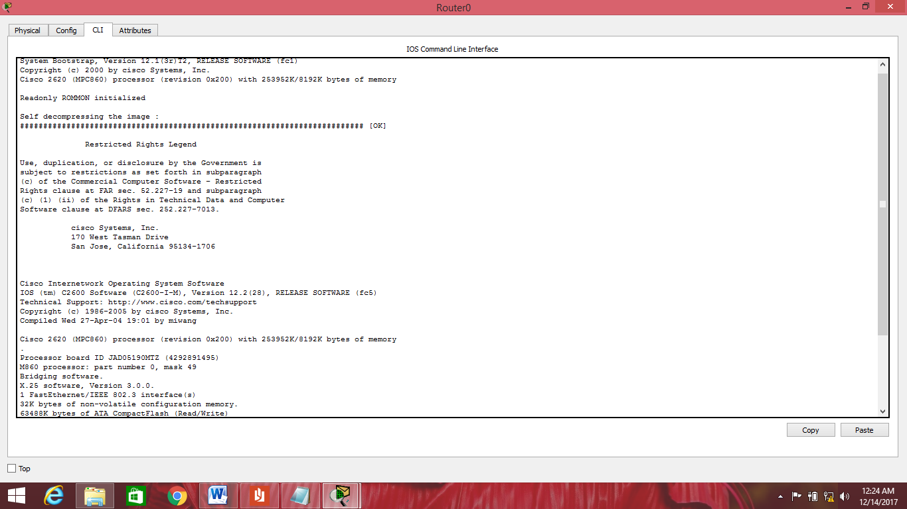

FIG 2.11 Cisco Router Version

Step 3 Next, configure the router name to be "IOS." To enter configuration mode, use the command configure terminal:

Router# configure terminal

Enter configuration commands, one per line. End with CNTL/Z.

Router(config)# hostname IOS

IOS(config)#

Notice that the prompt changes to "IOS" immediately after you enter the hostname command. All configuration changes in Cisco IOS take place immediately.

Step 4 Next, you need to set the enable password and the enable secret pass- word. The enable secret password is stored using stronger encryption and overrides the enable password if it is configured. To set both passwords, you enter the following:

IOS(config)# enable password cisco

IOS(config)# enable secret san-fran

IOS(config)# exit

IOS#

To get into enabled mode, you need to enter the password san-fran. The exit command takes you up one level in the configuration, or out of the current submode.

Step 5 After configuring the router name and setting the enable and enable secret passwords, you can examine the running configuration:

IOS# show running-config

Building configuration...

Current configuration : 743 bytes

!

version 12.2

service timestamps debug uptime

service timestamps log uptime

no service password-encryption

!

hostname IOS

!

enable secret 5 $1$IP7a$HClNetI.hpRdox84d.FYU.

enable password cisco

!

ip subnet-zero

!

call rsvp-sync

!

interface Ethernet0/0

noip address

shutdown

half-duplex

!

interface Serial0/0

noip address

shutdown

no fair-queue

!

interface Ethernet2/0

noip address

shutdown

half-duplex

!

interface Ethernet2/1

noip address

shutdown

half-duplex

!

interface Ethernet2/2

noip address

shutdown

half-duplex

!

interface Ethernet2/3

noip address

shutdown

half-duplex

!

ip classless

ip http server

ippimbidir-enable

!

dial-peercor custom

!

line con 0

line aux 0

linevty 0 4

!

end

Step 6 The show running-config output shows the configuration that is currently active in the system; however, this configuration is lost if the system is restarted. To save this configuration to NVRAM, you must issue the following command:

IOS# copy running-config startup-config

Destination filename [startup-config]?

Building configuration...

[OK]

Step 7 To view the startup configuration saved in NVRAM, use the command show startup-config.

In the preceding step sequence, notice the Ethernet and serial interfaces that show up in the configuration file. Each interface requires that certain parameters such as encapsulation and address be set before the interface can be used properly. In addition, IP routing or bridging might need to be configured. Refer to the Cisco IOS installation and configuration guides available at http://www.cisco.com for your version of software to learn about all possible configuration options and recommended guidelines.

**2.5 SERVICES**

**The Dynamic Host Configuration Protocol (DHCP)**

DHCP is a network management protocol used on TCP/IP networks whereby a DHCP server dynamically assigns an IP address and other network configuration parameters to each device on a network so they can communicate with other IP networks.[1] A DHCP server enables computers to request IP addresses and networking parameters automatically from the Internet service provider (ISP), reducing the need for a network administrator or a user to manually assign IP addresses to all network devices.[1] In the absence of a DHCP server, a computer or other device on the network needs to be manually assigned an IP address.

DHCP can be implemented on networks ranging in size from home networks to large campus networks and regional Internet service provider networks small local networks as well as large enterprise networks.[2] A router or a residential gateway can be enabled to act as a DHCP server. Most residential network routers receive a globally unique IP address within the ISP network. Within a local network, a DHCP server assigns a local IP address to each device connected to the network.

1) Client makes a UDP Broadcast to the server about the DHCP discovery.

2) DHCP offers to the client.

3) In response to the offer Client requests the server.

4)Server responds all the Ip Add/mask/gty/dns/wins info along with the acknowledgement packet.

**Secure Shell**

Secure Shell (SSH) is a cryptographic network protocol for operating network services securely over an unsecured network.[1] The best known example application is for remote login to computer systems by users.

SSH provides a secure channel over an unsecured network in a client-server architecture, connecting an SSH client application with an SSH server.[2] Common applications include remote command-line login and remote command execution, but any network service can be secured with SSH. The protocol specification distinguishes between two major versions, referred to as SSH-1 and SSH-2.

**Hypertext Transfer Protocol**

The Hypertext Transfer Protocol (HTTP) is an application protocol for distributed, collaborative, and hypermedia information systems.[1] HTTP is the foundation of data communication for the World Wide Web.

Hypertext is structured text that uses logical links (hyperlinks) between nodes containing text. HTTP is the protocol to exchange or transfer hypertext.

Development of HTTP was initiated by Tim Berners-Lee at CERN in 1989. Standards development of HTTP was coordinated by the Internet Engineering Task Force (IETF) and the World Wide Web Consortium (W3C), culminating in the publication of a series of Requests for Comments (RFCs). The first definition of HTTP/1.1, the version of HTTP in common use, occurred in RFC 2068 in 1997, although this was obsoleted by RFC 2616 in 1999 and then again by the RFC 7230 family of RFCs in 2014.

**Domain Name System**

The Domain Name System (DNS) is a hierarchical decentralized naming system for computers, services, or other resources connected to the Internet or a private network. It associates various information with domain names assigned to each of the participating entities. Most prominently, it translates more readily memorized domain names to the numerical IP addresses needed for locating and identifying computer services and devices with the underlying network protocols. By providing a worldwide, distributed directory service, the Domain Name System is an essential component of the functionality on the Internet, that has been in use since 1985.

**Telnet**

Telnet is a protocol used on the Internet or local area networks to provide a bidirectional interactive text-oriented communication facility using a virtual terminal connection. User data is interspersed in-band with Telnet control information in an 8-bit byte oriented data connection over the Transmission Control Protocol (TCP).

**Voice over IP(VOiP)**

Voice over Internet Protocol (also voice over IP, VoIP or IP telephony) is a methodology and group of technologies for the delivery of voice communications and multimedia sessions over Internet Protocol (IP) networks, such as the Internet. The terms Internet telephony, broadband telephony, and broadband phone service specifically refer to the provisioning of communications services (voice, fax, SMS, voice-messaging) over the public Internet, rather than via the public switched telephone network (PSTN).

**Firewall**

In computing, a firewall is a network security system that monitors and controls incoming and outgoing network traffic based on predetermined security rules. A firewall typically establishes a barrier between a trusted internal network and untrusted outside network, such as the Internet.

The Cisco ASA 5500 series is Cisco's follow up of the Cisco PIX 500 series firewall. However, the ASA is not just a pure hardware firewall. In brief, the Cisco ASA is a security device that combines firewall, antivirus, intrusion prevention, and virtual private network (VPN) capabilities. It provides proactive threat defense that stops attacks before they spread through the network. Indeed, Cisco ASA firewall is the whole package, so to speak.

**Spanning Tree Protocol**

The Spanning Tree Protocol (STP) is a network protocol that builds a logical loop-free topology for Ethernet networks. The basic function of STP is to prevent bridge loops and the broadcast radiation that results from them. Spanning tree also allows a network design to include backup links to provide fault tolerance if an active link fails.

As the name suggests, STP creates a spanning tree within a network of connected layer-2 bridges, and disables those links that are not part of the spanning tree, leaving a single active path between any two network nodes. STP is based on an algorithm that was invented by Radia Perlman while she was working for Digital Equipment Corporation.

**Cisco Configuration Professional**

Itoffers smart wizards and advanced configuration support for LAN and WAN interfaces, Network Address Translation (NAT), stateful and application firewall policy, IPS, IPSec and SSL VPN, QoS, and Cisco Network Admission Control policy features. The firewall wizard allows a single-step deployment of high, medium, or low firewall policy settings. IT managers can easily organize and manage multiple routers at a single site.

**Cisco Configuration Professional Offers:**

* One-click router lockdown
* Innovative voice and security auditing capabilities to check and recommend changes to router configurations
* Monitoring of router status
* Troubleshooting of WAN and VPN connectivity issues
* Cisco Configuration Professional Express is a GUI-based embedded device management tool for Cisco Integrated Services Routers (ISRs). It is available on the flash of the router and used for bootstrapping and basic configurations.

**Cisco Configuration Professional Express Offers:**

* Basic configuration of router WAN and LAN interfaces
* Hostname, Dynamic Name Server (DNS), and Dynamic Host Configuration Protocol (DHCP) configurations
* User Management for the router
* Configuration of plug-n-play server
* Dashboard, basic troubleshooting, and command line interface (CLI) tool

**2.6 CONFIGURATION**

**VLAN CONFIGURATION**

king#configure

Configuring from terminal, memory, or network [terminal]?

Enter configuration commands, one per line. End with CNTL/Z.

king(config)#int

king(config)#interface range fastEthernet 0/3 - 6

king(config-if-range)#sw

king(config-if-range)#switchport mode access

king(config-if-range)#switchport access vlan 3

king(config-if-range)#^Z

king#

%SYS-5-CONFIG_I: Configured from console by console

king#showvlan

VLAN Name Status Ports

---- -------------------------------- --------- -------------------------------

1 default active Fa0/7, Fa0/8, Fa0/9, Fa0/10

Fa0/11, Fa0/12, Fa0/13, Fa0/14

Fa0/15, Fa0/16, Fa0/17, Fa0/18

Fa0/19, Fa0/20, Fa0/21, Fa0/22

Fa0/23, Fa0/24

2 sales active Fa0/1, Fa0/2

3 Accounts active Fa0/3, Fa0/4, Fa0/5, Fa0/6

1002 fddi-default act/unsup

1003 token-ring-default act/unsup

1004 fddinet-default act/unsup

1005 trnet-default act/unsup

VLAN Type SAID MTU Parent RingNoBridgeNoStpBrdgMode Trans1 Trans2

---- ----- ---------- ----- ------ ------ -------- ---- -------- ------ ------

1 enet 100001 1500 - - - - - 0 0

2 enet 100002 1500 - - - - - 0 0

3 enet 100003 1500 - - - - - 0 0

1002 fddi 101002 1500 - - - - - 0 0

1003 tr 101003 1500 - - - - - 0 0

1004 fdnet 101004 1500 - - - ieee - 0 0

1005 trnet 101005 1500 - - - ibm - 0 0

Remote SPAN VLANs

------------------------------------------------------------------------------

Primary Secondary Type Ports

------- --------- ----------------- ------------------------------------------

%LINK-5-CHANGED: Interface FastEthernet0/1, changed state to up

%LINEPROTO-5-UPDOWN: Line protocol on Interface FastEthernet0/1, changed state to up

%LINK-5-CHANGED: Interface FastEthernet0/2, changed state to up

%LINEPROTO-5-UPDOWN: Line protocol on Interface FastEthernet0/2, changed state to up

%LINK-5-CHANGED: Interface FastEthernet0/3, changed state to up

%LINEPROTO-5-UPDOWN: Line protocol on Interface FastEthernet0/3, changed state to up

%LINK-5-CHANGED: Interface FastEthernet0/4, changed state to up

%LINEPROTO-5-UPDOWN: Line protocol on Interface FastEthernet0/4, changed state to up

king con0 is now available

Press RETURN to get started.

%LINK-5-CHANGED: Interface FastEthernet0/1, changed state to down

%LINEPROTO-5-UPDOWN: Line protocol on Interface FastEthernet0/1, changed state to down

king>en

king#config

Configuring from terminal, memory, or network [terminal]?

Enter configuration commands, one per line. End with CNTL/Z.

king(config)#intfa

king(config)#intfastEthernet 0/24

king(config-if)#sw

king(config-if)#switchport m

king(config-if)#switchport mode t

king(config-if)#switchport mode trunk

king(config-if)#

%LINK-5-CHANGED: Interface FastEthernet0/1, changed state to up

%LINEPROTO-5-UPDOWN: Line protocol on Interface FastEthernet0/1, changed state to up

king con0 is now available

Press RETURN to get started

%LINK-5-CHANGED: Interface FastEthernet0/1, changed state to down

%LINEPROTO-5-UPDOWN: Line protocol on Interface FastEthernet0/1, changed state to down

%LINK-5-CHANGED: Interface FastEthernet0/24, changed state to up

%LINEPROTO-5-UPDOWN: Line protocol on Interface FastEthernet0/24, changed state to up

**VTP CONFIGURATION**

Switch#configure

Configuring from terminal, memory, or network [terminal]?

Enter configuration commands, one per line. End with CNTL/Z.

Switch(config)#vtp ?

domain Set the name of the VTP administrative domain.

mode Configure VTP device mode

password Set the password for the VTP administrative domain

version Set the adminstrative domain to VTP version

Switch(config)#vtp d

Switch(config)#vtp domain ?

WORD Theascii name for the VTP administrative domain.

Switch(config)#int

Switch(config)#interface f0/1

Switch(config-if)#sw

Switch(config-if)#switchport m

Switch(config-if)#switchport mode ?

access Set trunking mode to ACCESS unconditionally

dynamic Settrunking mode to dynamically negotiate access or trunk mode

trunk Set trunking mode to TRUNK unconditionally

Switch(config-if)#switchport mode a

Switch(config-if)#switchport mode access

Switch(config-if)#sw

Switch(config-if)#switchportmo

Switch(config-if)#switchport mode t

Switch(config-if)#switchport mode trunk

Switch(config-if)#

%LINEPROTO-5-UPDOWN: Line protocol on Interface FastEthernet0/1, changed state to down

%LINEPROTO-5-UPDOWN: Line protocol on Interface FastEthernet0/1, changed state to up

Switch(config-if)#exit

Switch(config)#spanning-tree

% Incomplete command.

Switch(config)#spanning-tree ?

mode Spanning tree operating mode

portfast Spanning tree portfast options

vlan VLAN Switch Spanning Tree

Switch(config)#vt

Switch(config)#vtp d

Switch(config)#vtp domain ?

WORD Theascii name for the VTP administrative domain.

Switch(config)#vtp domain jetking

Changing VTP domain name from NULL to jetking

Switch(config)#^Z

Switch#

%SYS-5-CONFIG_I: Configured from console by console

Switch#shvtp status

VTP Version : 2

Configuration Revision : 0

Maximum VLANs supported locally : 255

Number of existing VLANs : 5

VTP Operating Mode : Server

VTP Domain Name : jetking

VTP Pruning Mode : Disabled

VTP V2 Mode : Disabled

VTP Traps Generation : Disabled

MD5 digest : 0x96 0xDB 0xDC 0x3A 0xBC 0x50 0x09 0x65

Configuration last modified by 0.0.0.0 at 0-0-00 00:00:00

Local updater ID is 0.0.0.0 (no valid interface found)

Switch#confi

Switch#configure

Configuring from terminal, memory,

or network [terminal]?

Enter configuration commands, one per line. End with CNTL/Z.

Switch(config)#vl

Switch(config)#vlan 2

Switch(config-vlan)#sa

Switch(config-vlan)#name sales

Switch(config-vlan)#^Z

Switch#

%SYS-5-CONFIG_I: Configured from console by console

Switch#shvl

Switch#shvlan

VLAN Name Status Ports

---- -------------------------------- --------- -------------------------------

1 default active Fa0/2, Fa0/3, Fa0/4, Fa0/5

Fa0/6, Fa0/7, Fa0/8, Fa0/9

Fa0/10, Fa0/11, Fa0/12, Fa0/13

Fa0/14, Fa0/15, Fa0/16, Fa0/17

Fa0/18, Fa0/19, Fa0/20, Fa0/21

Fa0/22, Fa0/23, Fa0/24, Gig1/1

Gig1/2

2 sales active

1002 fddi-default act/unsup

1003 token-ring-default act/unsup

1004 fddinet-default act/unsup

1005 trnet-default act/unsup

VLAN Type SAID MTU Parent RingNoBridgeNoStpBrdgMode Trans1 Trans2

---- ----- ---------- ----- ------ ------ -------- ---- -------- ------ ------

1 enet 100001 1500 - - - - - 0 0

2 enet 100002 1500 - - - - - 0 0

1002 fddi 101002 1500 - - - - - 0 0

1003 tr 101003 1500 - - - - - 0 0

1004 fdnet 101004 1500 - - - ieee - 0 0

1005 trnet 101005 1500 - - - ibm - 0 0

Remote SPAN VLANs

------------------------------------------------------------------------------

Primary Secondary Type Ports

------- --------- ----------------- ------------------------------------------

Switch#wr

Building configuration...

[OK]

**BACKUP FROM TFTP TO FLASH CONFIGURATION**

Press RETURN to get started!

Router>en

Router#config

Configuring from terminal, memory, or network [terminal]?

Enter configuration commands, one per line. End with CNTL/Z.

Router(config)#no ip domain lookup

Router(config)#int

Router(config)#int f0/0

Router(config-if)#ipaddres

Router(config-if)#ip address 10.0.0.1 255.0.0.0

Router(config-if)#no shut

%LINK-5-CHANGED: Interface FastEthernet0/0, changed state to up

%LINEPROTO-5-UPDOWN: Line protocol on Interface FastEthernet0/0, changed state to up

Router(config-if)#^Z

Router#

%SYS-5-CONFIG_I: Configured from console by console

Router#copy ?

flash: Copy from flash: file system

ftp: Copy from ftp: file system

running-config Copy from current system configuration

startup-config Copy from startup configuration

tftp: Copy from tftp: file system

Router#sh version

Cisco Internetwork Operating System Software

IOS (tm) C2600 Software (C2600-I-M), Version 12.2(28), RELEASE SOFTWARE (fc5)

Technical Support: http://www.cisco.com/techsupport

Copyright (c) 1986-2005 by cisco Systems, Inc.

Compiled Wed 27-Apr-04 19:01 by miwang

Image text-base: 0x8000808C, data-base: 0x80A1FECC

ROM: System Bootstrap, Version 12.1(3r)T2, RELEASE SOFTWARE (fc1)

Copyright (c) 2000 by cisco Systems, Inc.

ROM: C2600 Software (C2600-I-M), Version 12.2(28), RELEASE SOFTWARE (fc5)

System returned to ROM by reload

System image file is "flash:c2600-i-mz.122-28.bin"

cisco 2620 (MPC860) processor (revision 0x200) with 60416K/5120K bytes of memory

.

Processor board ID JAD05190MTZ (4292891495)

M860 processor: part number 0, mask 49

Bridging software.

X.25 software, Version 3.0.0.

1 FastEthernet/IEEE 802.3 interface(s)

2 Low-speed serial(sync/async) network interface(s)

32K bytes of non-volatile configuration memory.

Router#show flash

System flash directory:

File Length Name/status

3 5571584 c2600-i-mz.122-28.bin

2 28282 sigdef-category.xml

1 227537 sigdef-default.xml

[5827403 bytes used, 58188981 available, 64016384 total]

63488K bytes of processor board System flash (Read/Write)

Router#copy ?

flash: Copy from flash: file system

ftp: Copy from ftp: file system

running-config Copy from current system configuration

startup-config Copy from startup configuration

tftp: Copy from tftp: file system

Router#copy flash t?

tftp:

Router#show flash tftp

^

% Invalid input detected at '^' marker.

Router#copy flash tftp

Source filename []?c2600-i-mz.122-28.bin

Address or name of remote host []?

?Host name or address not specified

Router#copy flash tftp

Source filename []?c2600-i-mz.122-28.bin

Address or name of remote host []? 10.0.0.2

Destination filename [c2600-i-mz.122-28.bin]?

Writing c2600-i-mz.122-28.bin...!!!!!!!!!!!!!!!!!!!!!!!!!!!!!!!!!!!!!!!!!!!!!!!!!!!!!!!!!!!!!!!!!!!!!!!!!!!!!!!!!!!!!!!!!!!!!!!!!!!!!!!!!!!!!!

[OK - 5571584 bytes]

5571584 bytes copied in 3.375 secs (1650000 bytes/sec)

Router#copytftp ?

flash: Copy to flash: file system

running-config Copy configuration from system

startup-config Copy startup configuration from system

Router#copytftp flash

Address or name of remote host []?c2600-i-mz.122-28.bin

Source filename []?

?File name not specified

%Error parsing filename (Unknown error 0)

Router#copytftp flash

Address or name of remote host []? 10.0.0.1

Source filename []?c2600-i-mz.122-28.bin

Destination filename [c2600-i-mz.122-28.bin]?

%Warning:There is a file already existing with this name

Do you want to over write? [confirm]

Erase flash: before copying? [confirm]

Erasing the flash filesystem will remove all files! Continue? [confirm]

Erasing device... eeeeeeeeeeeeeeeeeeeeeeeeeeeeeeeeeeeeeeeeeeeeeeeeeeeeeeeeeeeeeeeeeeeeeeeeeeeeeeeeeeeeeeeeeeeeeeeeeeeeeeeeeeeeeeeeeeeeeeeeeeeeeeeeeeeeeeeeeeeee ...erased

Erase of flash: complete

Accessing tftp://10.0.0.1/c2600-i-mz.122-28.bin........

%Error opening tftp://10.0.0.1/c2600-i-mz.122-28.bin (Timed out)

**PORT SECURITY CONFIGURATION**

Switch(config)#int f0/1

Switch(config-if)#switchport mode access

Switch(config-if)#switchport port-security

Switch(config-if)#switchport port-security mac

Switch(config-if)#switchport port-security mac-address max 1 ?

% Unrecognized command

Switch(config-if)#switchport port-security mac-address 1

^

% Invalid input detected at '^' marker.

Switch(config-if)#switchport port-security ?

mac-address Secure mac address

maximum Max secure addresses

violation Security violation mode

<cr>

Switch(config-if)#switchport port-security maximum 1

Switch(config-if)#switchport port-security mac-address sticky

Switch(config-if)#switchport port-security ?

mac-address Secure mac address

maximum Max secure addresses

violation Security violation mode

<cr>

Switch(config-if)#switchport port-security violation shutdown

Switch(config-if)#^Z

Switch#

%SYS-5-CONFIG_I: Configured from console by console

Switch#sh running-config

Building configuration...

Current configuration : 1165 bytes

!

version 12.2

no service timestamps log datetimemsec

no service timestamps debug datetimemsec

no service password-encryption

!

hostname Switch

!

!

interface FastEthernet0/1

switchport mode access

switchport port-security

switchport port-security mac-address sticky

switchport port-security mac-address sticky 0001.9641.B966

!

interface FastEthernet0/2

!

interface FastEthernet0/3

--More--

%LINK-5-CHANGED: Interface FastEthernet0/1, changed state to down

%LINEPROTO-5-UPDOWN: Line protocol on Interface FastEthernet0/1, changed state to down

%LINK-5-CHANGED: Interface FastEthernet0/1, changed state to up

%LINEPROTO-5-UPDOWN: Line protocol on Interface FastEthernet0/1, changed state to up

%LINK-5-CHANGED: Interface FastEthernet0/1, changed state to administratively down

%LINEPROTO-5-UPDOWN: Line protocol on Interface FastEthernet0/1, changed state to down

**DYNAMIC NAT CONFIGURATION**

Router#CONFIgure

Configuring from terminal, memory, or network [terminal]?

Enter configuration commands, one per line. End with CNTL/Z.

Router(config)#AC

Router(config)#ACcess-list 1 PER

Router(config)#ACcess-list 1 PERmit 10.0.0.0 0.255.255.255 ?

<cr>

Router(config)#ACcess-list 1 PERmit 10.0.0.0 0.255.255.255

Router(config)#IP NAT

Router(config)#IP NAT ?

insideInside address translation

outside Outside address translation

pool Define pool of addresses

Router(config)#IP NAT POO

Router(config)#IP NAT POOl JETKING ?

A.B.C.D Start IP address

Router(config)#IP NAT POOl JETKING 122.1.1.1 122.1.1.4 ?

netmask Specify the network mask

Router(config)#IP NAT POOl JETKING 122.1.1.1 122.1.1.4 NET

Router(config)#IP NAT POOl JETKING 122.1.1.1 122.1.1.4 NETmask 255.255.255.0 ?

<cr>

Router(config)#IP NAT POOl JETKING 122.1.1.1 122.1.1.4 NETmask 255.255.255.0

Router(config)#IP NAT

Router(config)#IP NAT ?

insideInside address translation

outside Outside address translation

pool Define pool of addresses

Router(config)#IP NAT INsideSOurceLIst 1 POOl JETKING

Router(config)#IP NAT INsideSOurceLIst 1 POOl JETKING?

WORD

Router(config)#IP NAT INsideSOurceLIst 1 POOl JETKING

Router(config)#INT F0/0

Router(config-if)#IP NAT

Router(config-if)#IP NAT IN

Router(config-if)#IP NAT INside

Router(config-if)#ZCONFI

Router(config-if)#^Z

Router#

%SYS-5-CONFIG_I: Configured from console by console

Router#CONFIgure

Configuring from terminal, memory, or network [terminal]?

Enter configuration commands, one per line. End with CNTL/Z.

Router(config)#

Router(config)#

Router(config)#INT S0/0

Router(config-if)#IP NA

Router(config-if)#IP NAt O

Router(config-if)#IP NAt Outside ^Z

Router#

%SYS-5-CONFIG_I: Configured from console by console

Router#SHow IP NAT TR

Router#SHow IP NAT TRanslations

Router#SHow IP NAT TRanslations

Pro Inside global Inside local Outside local Outside global

icmp 122.1.1.1:5 10.0.0.2:5 204.1.1.10:5 204.1.1.10:5

icmp 122.1.1.1:6 10.0.0.2:6 204.1.1.10:6 204.1.1.10:6

icmp 122.1.1.1:7 10.0.0.2:7 204.1.1.10:7 204.1.1.10:7

icmp 122.1.1.1:8 10.0.0.2:8 204.1.1.10:8 204.1.1.10:8

tcp 122.1.1.2:1026 10.0.0.3:1026 204.1.1.10:80 204.1.1.10:80

Router#SHow IP NAT TRanslations

Pro Inside global Inside local Outside local Outside global

tcp 122.1.1.2:1026 10.0.0.3:1026 204.1.1.10:80 204.1.1.10:80

tcp 122.1.1.3:1025 10.0.0.4:1025 204.1.1.10:80 204.1.1.10:80

Router#

STATIC NAT CONFIGURATION

Router(config-if)#

Router(config-if)#^Z

Router#

%SYS-5-CONFIG_I: Configured from console by console

%LINK-5-CHANGED: Interface Serial0/0, changed state to up

%LINEPROTO-5-UPDOWN: Line protocol on Interface Serial0/0, changed state to up

Router#CONFI

Router#CONFIgure

Configuring from terminal, memory, or network [terminal]?

Enter configuration commands, one per line. End with CNTL/Z.

Router(config)#ROUter Rip

Router(config-router)#V

Router(config-router)#Version 2

Router(config-router)#NET

Router(config-router)#NETwork 10.0.0.0

Router(config-router)#NET

Router(config-router)#NETwork 122.1.1.0

Router(config-router)#^Z

Router#

%SYS-5-CONFIG_I: Configured from console by console

Router#SH

Router#SHow NA

Router#SHowNAT ?

% Unrecognized command

Router#SHowIP ?

access-lists List access lists

arp IP ARP table

bgp BGP information

dhcp Show items in the DHCP database

eigrp IP-EIGRP show commands

interface IP interface status and configuration

nat IP NAT information

nbar Network-Based Application Recognition

ospf OSPF information

protocols IP routing protocol process parameters and statistics

rip IP RIP show commands

route IP routing table

ssh Information on SSH

Router#SHow IP NAT

Router#SHow IP NAT ?

statistics Translation statistics

translations Translation entries

Router#SHow IP NAT TR

Router#SHow IP NAT TRanslations

Router#CONF

Router#CONFigure

Configuring from terminal, memory, or network [terminal]?

Enter configuration commands, one per line. End with CNTL/Z.

Router(config)#IP NAT

Router(config)#IP NAT ?

insideInside address translation

outside Outside address translation

pool Define pool of addresses

Router(config)#IP NAT INS

Router(config)#IP NAT INSide ?

source Source address translation

Router(config)#IP NAT INSide SO

Router(config)#IP NAT INSideSOurce ?

list Specify access list describing local addresses

static Specify static local->global mapping

Router(config)#IP NAT INSideSOurce ST

Router(config)#IP NAT INSideSOurceSTatic ?

A.B.C.D Inside local IP address

tcp Transmission Control Protocol

udp User Datagram Protocol

Router(config)#IP NAT INSideSOurceSTatic 10.0.0.2 ?

A.B.C.D Inside global IP address

Router(config)#IP NAT INSideSOurceSTatic 10.0.0.2 122.1.1.2 ?

<cr>

Router(config)#IP NAT INSideSOurceSTatic 10.0.0.2 122.1.1.2

Router(config)#IP NAT INSideSOurceSTatic 10.0.0.3 122.1.1.3

Router(config)#^Z

Router#

%SYS-5-CONFIG_I: Configured from console by console

Router#

Router#

Router#

Router#SH IP NAT

Router#SH IP NAT TR

Router#SH IP NAT TRanslations

Pro Inside global Inside local Outside local Outside global

--- 122.1.1.2 10.0.0.2 --- ---

--- 122.1.1.3 10.0.0.3 --- ---

Router#CONF

Router#CONFigure

Configuring from terminal, memory, or network [terminal]?

Enter configuration commands, one per line. End with CNTL/Z.

Router(config)#INT F0/0

Router(config-if)#IP NAT ?

insideInside interface for address translation

outside Outside interface for address translation

Router(config-if)#IP NAT IN

Router(config-if)#IP NAT INside

Router(config-if)#INT

Router(config-if)#^Z

Router#

%SYS-5-CONFIG_I: Configured from console by console

Router#

Router#

Router#INT S0/0

^

% Invalid input detected at '^' marker.

Router#CONFIG

Router#CONFIGure

Configuring from terminal, memory, or network [terminal]?

Enter configuration commands, one per line. End with CNTL/Z.

Router(config)#

Router(config)#INT S0/0

Router(config-if)#IP NAT OU

Router(config-if)#IP NAT OUtside

Router(config-if)#^Z

Router#

%SYS-5-CONFIG_I: Configured from console by console

Router#SH IP NA

Router#SH IP NAt T

Router#SH IP NAt Translations

Pro Inside global Inside local Outside local Outside global

--- 122.1.1.2 10.0.0.2 --- ---

--- 122.1.1.3 10.0.0.3 --- ---

Router#SH IP NAt Translations

Pro Inside global Inside local Outside local Outside global

icmp 122.1.1.2:1 10.0.0.2:1 204.1.1.10:1 204.1.1.10:1

icmp 122.1.1.2:2 10.0.0.2:2 204.1.1.10:2 204.1.1.10:2

icmp 122.1.1.2:3 10.0.0.2:3 204.1.1.10:3 204.1.1.10:3

icmp 122.1.1.2:4 10.0.0.2:4 204.1.1.10:4 204.1.1.10:4

--- 122.1.1.2 10.0.0.2 --- ---

--- 122.1.1.3 10.0.0.3 --- ---

Router#SH IP NAt Translations

Pro Inside global Inside local Outside local Outside global

--- 122.1.1.2 10.0.0.2 --- ---

--- 122.1.1.3 10.0.0.3 --- ---

tcp 122.1.1.2:1026 10.0.0.2:1026 204.1.1.10:80 204.1.1.10:80

Router#SH IP NAt Translations

Pro Inside global Inside local Outside local Outside global

--- 122.1.1.2 10.0.0.2 --- ---

--- 122.1.1.3 10.0.0.3 --- ---

tcp 122.1.1.2:1026 10.0.0.2:1026 204.1.1.10:80 204.1.1.10:80

tcp 122.1.1.3:1025 10.0.0.3:1025 204.1.1.10:80 204.1.1.10:80

VOIP configuration

!

!

!

!

!

interface FastEthernet0/0

ip address 10.0.0.2 255.0.0.0

duplex auto

speed auto

!

interface FastEthernet0/1

ip address 20.0.0.1 255.0.0.0

duplex auto

speed auto

!

interface Serial0/0/0

noip address

clock rate 2000000

shutdown

!

interface Serial0/0/1

noip address

clock rate 2000000

shutdown

!

interface Serial0/1/0

noip address

clock rate 2000000

shutdown

!

interface Serial0/1/1

noip address

clock rate 2000000

shutdown

!

interface Serial0/2/0

noip address

clock rate 2000000

shutdown

!

interface Serial0/2/1

noip address

clock rate 2000000

shutdown

!

interface Serial0/3/0

noip address

clock rate 2000000

shutdown

!

interface Serial0/3/1

noip address

clock rate 2000000

shutdown

!

interface Ethernet1/0

ip address 192.168.2.1 255.255.255.0

duplex auto

speed auto

!

interface Vlan1

noip address

shutdown

!

routerospf 20

log-adjacency-changes

network 10.0.0.0 0.255.255.255 area 0

network 20.0.0.0 0.255.255.255 area 0

!

ip classless

!

ip flow-export version 9

!

!

!

!

!

!

!

line con 0

password cisco

login

!

line aux 0

!

linevty 0 4

login

!

!

!

end

Router1#conf

Router1#configure

Router1#configure terminal

Enter configuration commands, one per line. End with CNTL/Z.

Router1(config)#int

Router1(config)#interface eth

Router1(config)#interface ethernet 1/0

Router1(config-if)#ip dh

Router1(config-if)#ipdhc

Router1(config-if)#ex

Router1(config-if)#exit

Router1(config)#ip dh

Router1(config)#ipdhcp poo

Router1(config)#ipdhcp pool IpPHONE

Router1(dhcp-config)#net

Router1(dhcp-config)#network 192.168.2.0 255.255.255.0

Router1(dhcp-config)#def

Router1(dhcp-config)#default-router 192.168.2.1

Router1(dhcp-config)#opt

Router1(dhcp-config)#option ?

<0-254> DHCP option code

Router1(dhcp-config)#option 150 ?

ip Data is one or more IP addresses

Router1(dhcp-config)#option 150 192.168.2.1 ?

% Unrecognized command

Router1(dhcp-config)#option 150 i

Router1(dhcp-config)#option 150 ip 192.168.2.1 ?

<cr>

Router1(dhcp-config)#option 150 ip 192.168.2.1

Router1(dhcp-config)#ex

Router1(dhcp-config)#exit

Router1(config)#tele

Router1(config)#telephony-service

Router1(config-telephony)#max

Router1(config-telephony)#max-

Router1(config-telephony)#max-ephones ?

<1-42> Maximum phones to support

Router1(config-telephony)#max-ephones 10

Router1(config-telephony)#max-dn

Router1(config-telephony)#max-dn ?

<1-144> Maximum directory numbers supported

Router1(config-telephony)#max-dn 10

Router1(config-telephony)#ipsou

Router1(config-telephony)#ip source-address 192.168.2.1 po

Router1(config-telephony)#ip source-address 192.168.2.1 port ?

<2000-9999> Specify the port: 2000 - 9999

Router1(config-telephony)#ip source-address 192.168.2.1 port 2000

Router1(config-telephony)#aut

Router1(config-telephony)#auto ass

Router1(config-telephony)#auto assign ?

<1-144> startdn tag

Router1(config-telephony)#auto assign 8 t

Router1(config-telephony)#auto assign 8 to 11 ?

<cr>

Router1(config-telephony)#auto assign 8 to 11

Router1(config-telephony)#aut

Router1(config-telephony)#aut

Router1(config-telephony)#auto ass

Router1(config-telephony)#auto assign 1 t

Router1(config-telephony)#auto assign 1 to 9

Router1(config-telephony)#ex

Router1(config-telephony)#exit

Router1(config)#eph

Router1(config)#ephone

Router1(config)#ephone-dn 1

Router1(config-ephone-dn)#%LINK-3-UPDOWN: Interface ephone_dsp DN 1.1, changed state to up

Router1(config-ephone-dn)#numbe

Router1(config-ephone-dn)#number ?

WORD A sequence of digits - representing telephone number

Router1(config-ephone-dn)#number 7409753364

Router1(config-ephone-dn)#ephone-dn 2

Router1(config-ephone-dn)#%LINK-3-UPDOWN: Interface ephone_dsp DN 2.1, changed state to up

Router1(config-ephone-dn)#number 7409753375

Router1(config-ephone-dn)#ephone-dn 3

Router1(config-ephone-dn)#%LINK-3-UPDOWN: Interface ephone_dsp DN 3.1, changed state to up

Router1(config-ephone-dn)#number 7409753385

Router1(config-ephone-dn)#ephone-dn 4

Router1(config-ephone-dn)#%LINK-3-UPDOWN: Interface ephone_dsp DN 4.1, changed state to up

Router1(config-ephone-dn)#number 7409753395

Router1(config-ephone-dn)#ephone-dn 5

Router1(config-ephone-dn)#%LINK-3-UPDOWN: Interface ephone_dsp DN 5.1, changed state to up

Router1(config-ephone-dn)#number 74097533105

Router1(config-ephone-dn)#ephone-dn 6

Router1(config-ephone-dn)#%LINK-3-UPDOWN: Interface ephone_dsp DN 6.1, changed state to up

Router1(config-ephone-dn)#number 74097533120

VOIP CONFIGURATION (on switch)

C2950 Boot Loader (C2950-HBOOT-M) Version 12.1(11r)EA1, RELEASE SOFTWARE (fc1)

Compiled Mon 22-Jul-02 18:57 by miwang

Cisco WS-C2950-24 (RC32300) processor (revision C0) with 21039K bytes of memory.

2950-24 starting...

Base ethernet MAC Address: 00E0.F731.5D30

Xmodem file system is available.

Initializing Flash...

flashfs[0]: 2 files, 0 directories

flashfs[0]: 0 orphaned files, 0 orphaned directories

flashfs[0]: Total bytes: 64016384

flashfs[0]: Bytes used: 3058664

flashfs[0]: Bytes available: 60957720

flashfs[0]: flashfsfsck took 1 seconds.

...done Initializing Flash.

Boot Sector Filesystem (bs:) installed, fsid: 3

Parameter Block Filesystem (pb:) installed, fsid: 4

Loading "flash:/c2950-i6q4l2-mz.121-22.EA4.bin"...

######################### [OK]

Restricted Rights Legend

Use, duplication, or disclosure by the Government is

subject to restrictions as set forth in subparagraph

(c) of the Commercial Computer Software - Restricted

Rights clause at FAR sec. 52.227-19 and subparagraph

(c) (1) (ii) of the Rights in Technical Data and Computer

Software clause at DFARS sec. 252.227-7013.

cisco Systems, Inc.

170 West Tasman Drive

San Jose, California 95134-1706

Cisco Internetwork Operating System Software

IOS (tm) C2950 Software (C2950-I6Q4L2-M), Version 12.1(22)EA4, RELEASE SOFTWARE(fc1)

Copyright (c) 1986-2005 by cisco Systems, Inc.

Compiled Wed 18-May-05 22:31 by jharirba

Cisco WS-C2950-24 (RC32300) processor (revision C0) with 21039K bytes of memory.

Processor board ID FHK0610Z0WC

Running Standard Image

24 FastEthernet/IEEE 802.3 interface(s)

63488K bytes of flash-simulated non-volatile configuration memory.

Base ethernet MAC Address: 00E0.F731.5D30

Motherboard assembly number: 73-5781-09

Power supply part number: 34-0965-01

Motherboard serial number: FOC061004SZ

Power supply serial number: DAB0609127D

Model revision number: C0

Motherboard revision number: A0

Model number: WS-C2950-24

System serial number: FHK0610Z0WC

Cisco Internetwork Operating System Software

IOS (tm) C2950 Software (C2950-I6Q4L2-M), Version 12.1(22)EA4, RELEASE SOFTWARE(fc1)

Copyright (c) 1986-2005 by cisco Systems, Inc.

Compiled Wed 18-May-05 22:31 by jharirba

Press RETURN to get started!

%LINK-5-CHANGED: Interface FastEthernet0/1, changed state to up

%LINEPROTO-5-UPDOWN: Line protocol on Interface FastEthernet0/1, changed state to up

%LINK-5-CHANGED: Interface FastEthernet0/5, changed state to up

%LINEPROTO-5-UPDOWN: Line protocol on Interface FastEthernet0/5, changed state to up

%LINK-5-CHANGED: Interface FastEthernet0/6, changed state to up

%LINEPROTO-5-UPDOWN: Line protocol on Interface FastEthernet0/6, changed state to up

%LINK-5-CHANGED: Interface FastEthernet0/7, changed state to up

%LINEPROTO-5-UPDOWN: Line protocol on Interface FastEthernet0/7, changed state to up

%LINK-5-CHANGED: Interface FastEthernet0/8, changed state to up

%LINEPROTO-5-UPDOWN: Line protocol on Interface FastEthernet0/8, changed state to up

%LINK-5-CHANGED: Interface FastEthernet0/2, changed state to up

%LINEPROTO-5-UPDOWN: Line protocol on Interface FastEthernet0/2, changed state to up

Switch>en

Switch#

Switch#conf

Switch#configure

Switch#configure terminal

Enter configuration commands, one per line. End with CNTL/Z.

Switch(config)#int

Switch(config)#interface rang

Switch(config)#interface range Fa

Switch(config)#interface range FastEthernet 0/1 ?

, comma

- hyphen

<cr>

Switch(config)#interface range FastEthernet 0/1 - 0/24

^

% Invalid input detected at '^' marker.

Switch(config)#interface range FastEthernet 0/1 - 24

Switch(config-if-range)#switchport mode access

Switch(config-if-range)#switchport voice vlan 1

Switch(config-if-range)#exit

Switch(config)#exit

Switch#

%SYS-5-CONFIG_I: Configured from console by console

sh

Switch#showvl

Switch#showvlanbr

Switch#showvlan brief

VLAN Name Status Ports

---- -------------------------------- --------- -------------------------------

1 default active Fa0/1, Fa0/2, Fa0/3, Fa0/4

Fa0/5, Fa0/6, Fa0/7, Fa0/8

Fa0/9, Fa0/10, Fa0/11, Fa0/12

Fa0/13, Fa0/14, Fa0/15, Fa0/16

Fa0/17, Fa0/18, Fa0/19, Fa0/20

Fa0/21, Fa0/22, Fa0/23, Fa0/24

5 Voice active

1002 fddi-default active

1003 token-ring-default active

1004 fddinet-default active

1005 trnet-default active

CHAPTER 3: EXPERIMENTAL RESULT

**3.1MERITES**

* **Easily make the blueprints**

Whenever we have to make any network architecture or any network topology then first of all we have to make the blueprints of the network rather then directly start implementing it on real devices.

* **Time saver**

This technology is too much time saving we don’t have to wait for anything to load or anything all work goes with the smooth flow.

* **Easy to implement**

This is very easy to implement when we do this on simulation software. Its easy on the real devices too but then you have to do a lot of physical work too like powering on the device put cables to different locations etc.

* **Easy to find errors**in this it is easy to find the errors, we can easily capture the error by transmitting packet from source to destination, if the packet sent successfully then its good and if it fails means there is some error.
* **Hands on to the devices you don’t have**we can easily use the latest routers/switches etc. any network component if we need . we don’t have to purchase it in order to use it

CHAPTER 4: CONCLUSION AND FUTURE SCOPE

**4.1 FUTURE SCOPE**

* **WAN TECHNOLOGY**

WANs are all about exchanging information across wide geographic areas. They are also, as you can probably gather from reading about the Internet, about scalability—the ability to grow to accommodate the number of users on the network, as well as to accommodate the demands those users place on network facilities. Although the nature of a WAN—a network reliant on communications for covering sometimes vast distances—generally dictates slower throughput, longer delays, and a greater number of errors than typically occur on a LAN, a WAN is also the fastest, most effective means of transferring computer-based information currently available.

OUTPUT PAGES

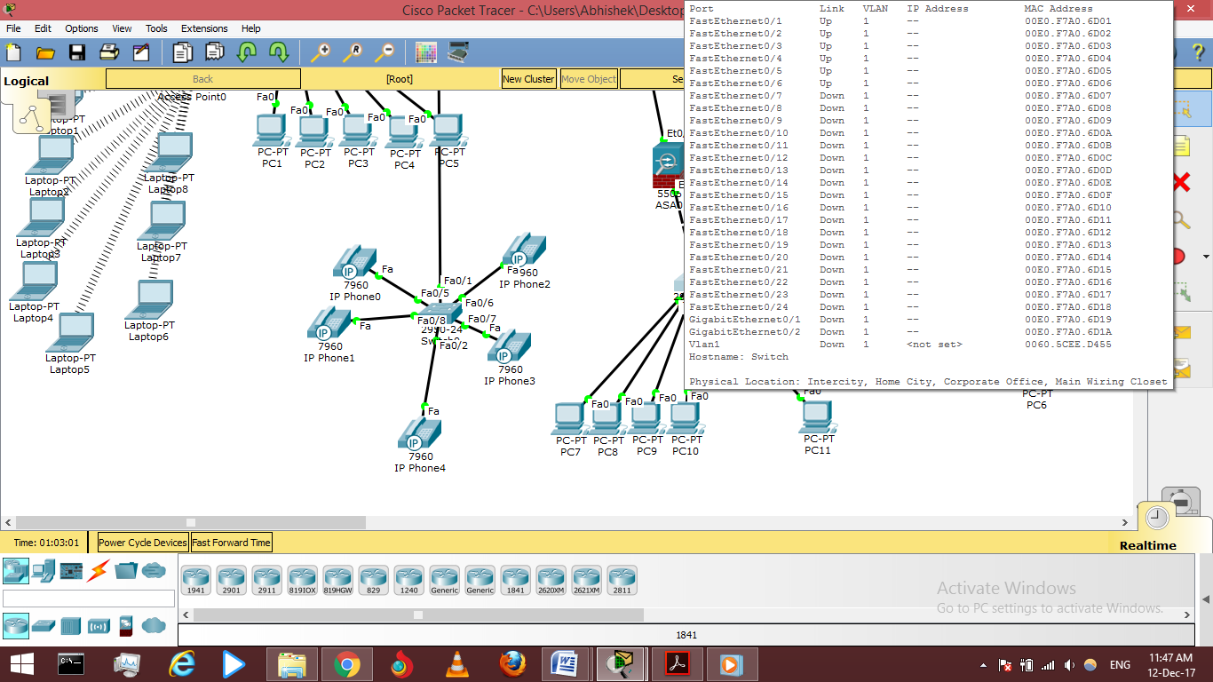

FIG 4.1 Basic Topology

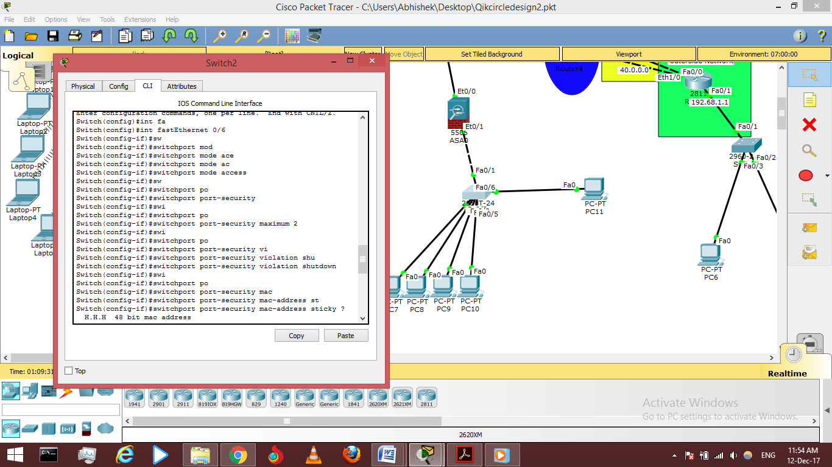

FIG 4.2 Configuring Cisco Switch

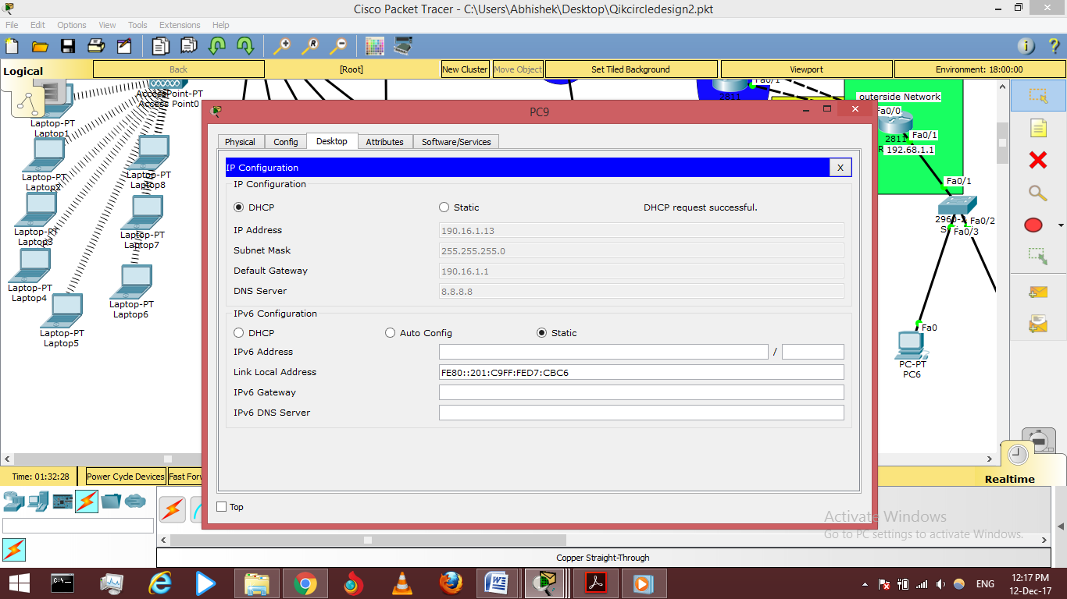

FIG 4.3 Configuring Client PC’s

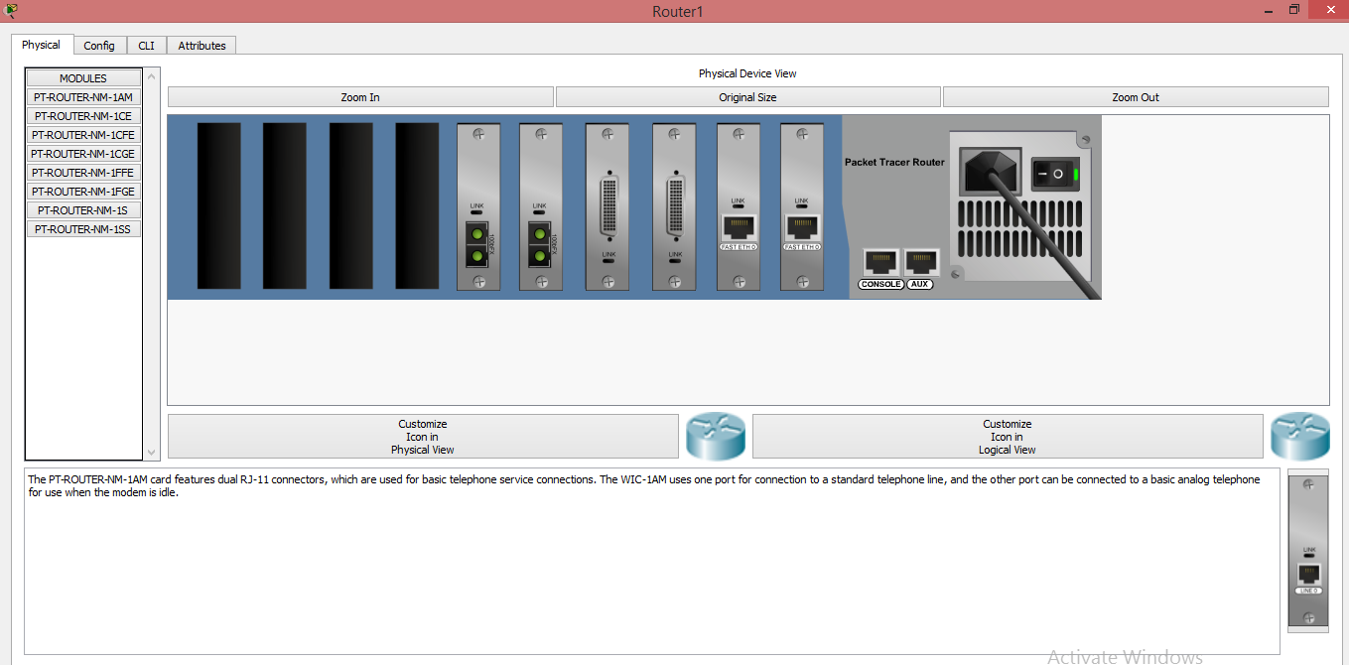

FIG 4.4 Configuring Cisco Router

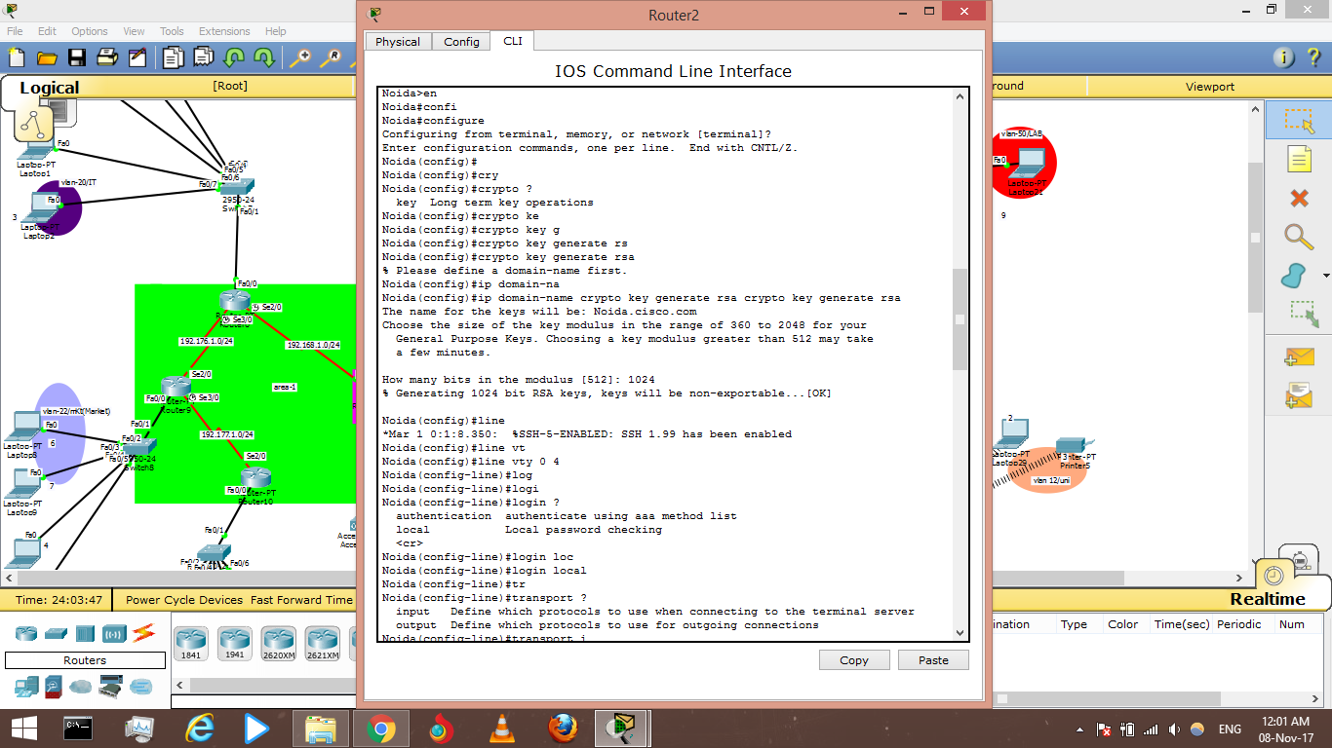

FIG 4.5 Configuring ssh Router

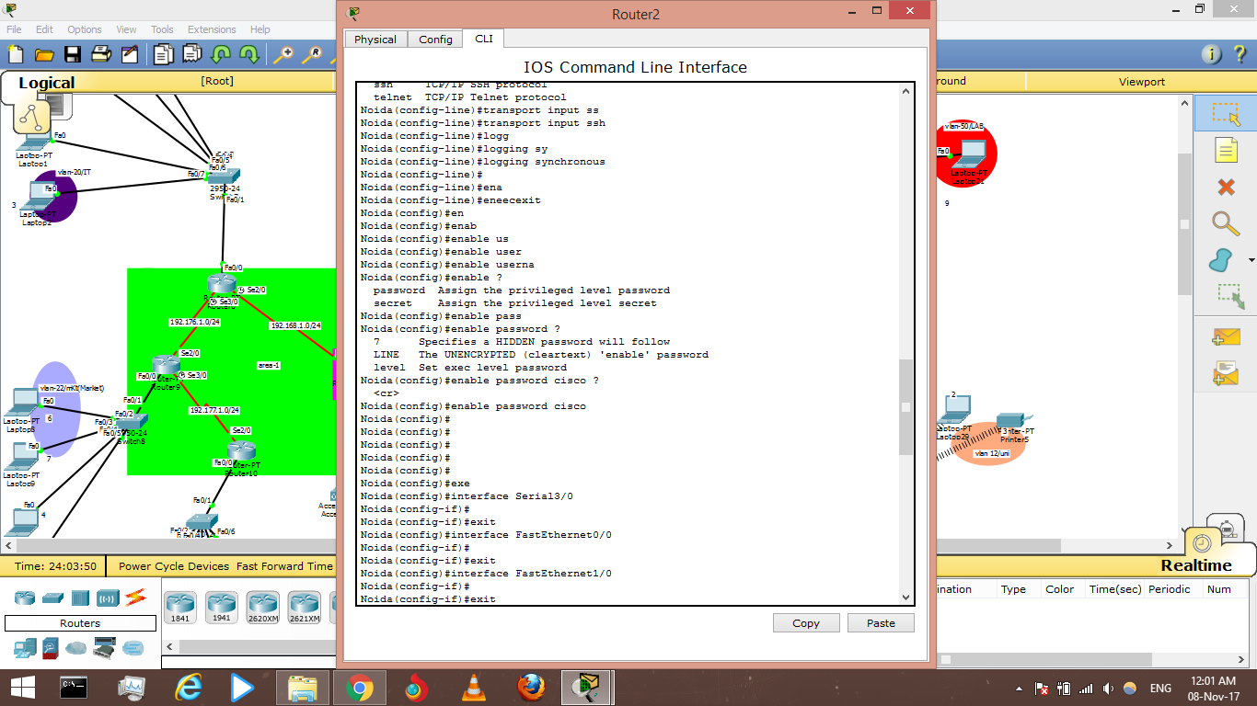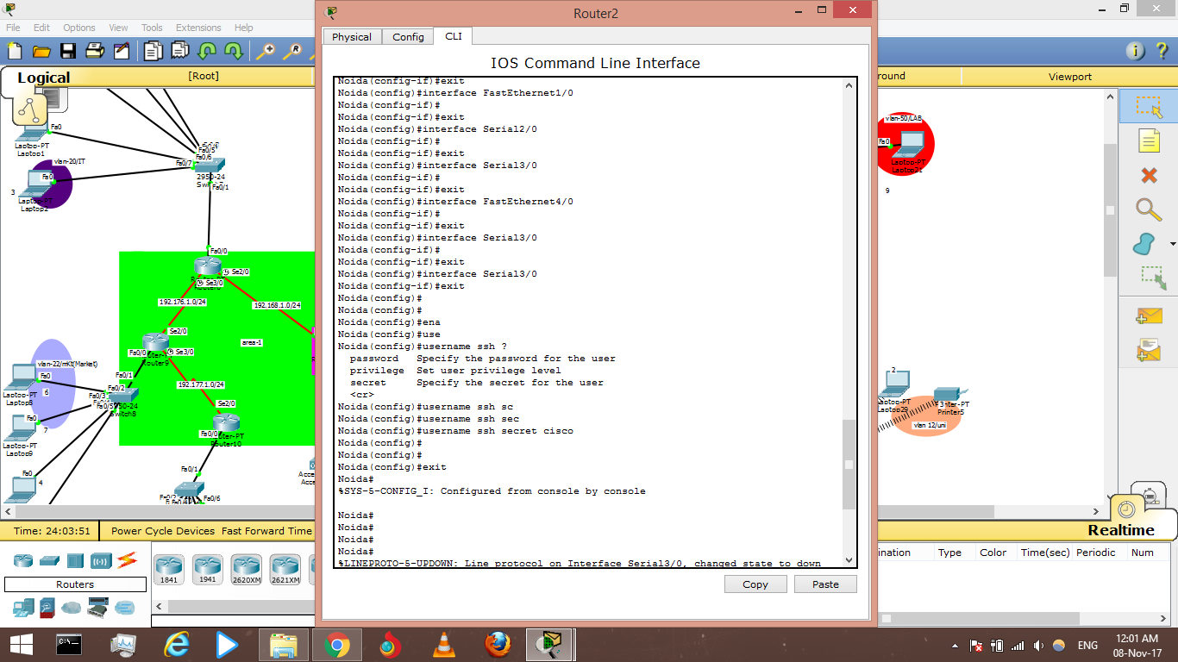

FIG 4.6 Configuring ssh(2) Router

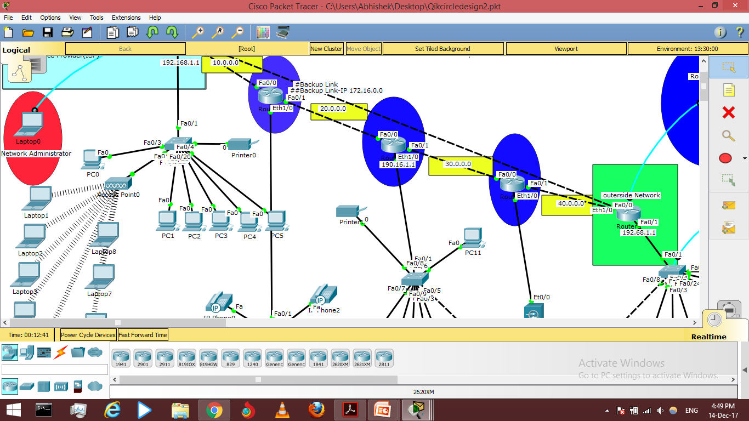

FIG 4.7 Design

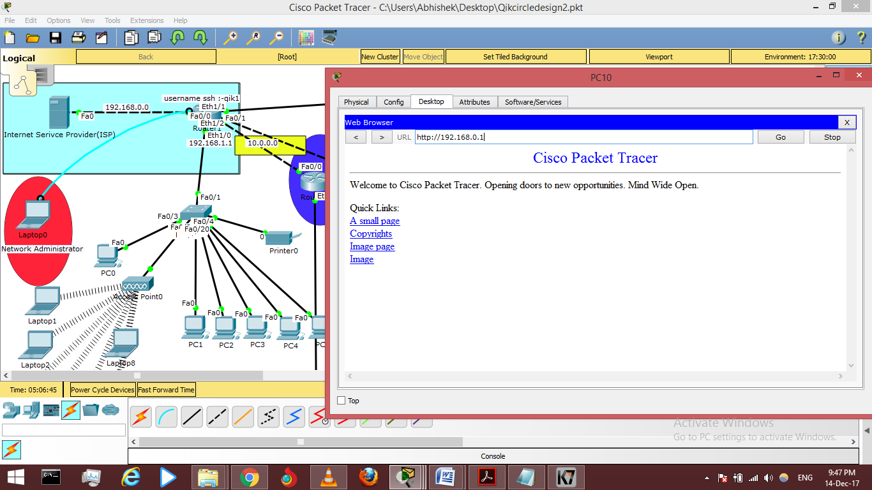

FIG 4.6 Device Connect To HTTP server

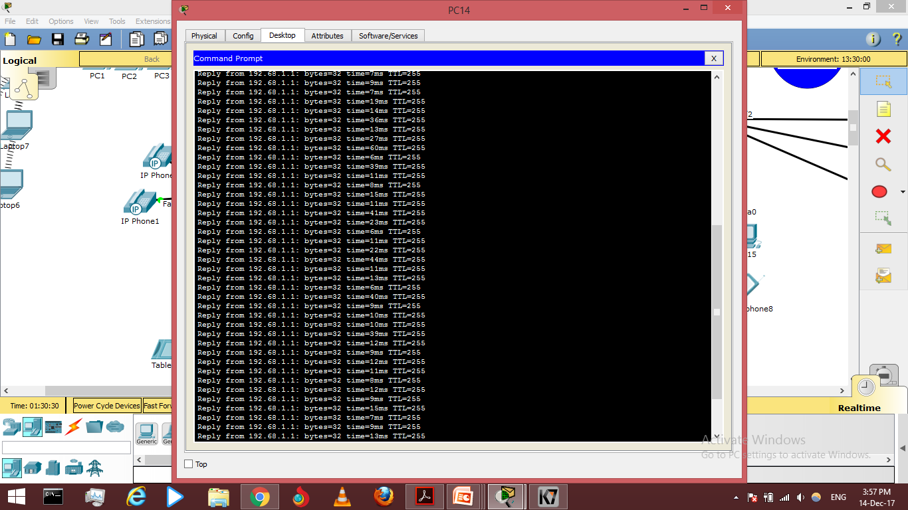

FIG 4.7 Ping reply

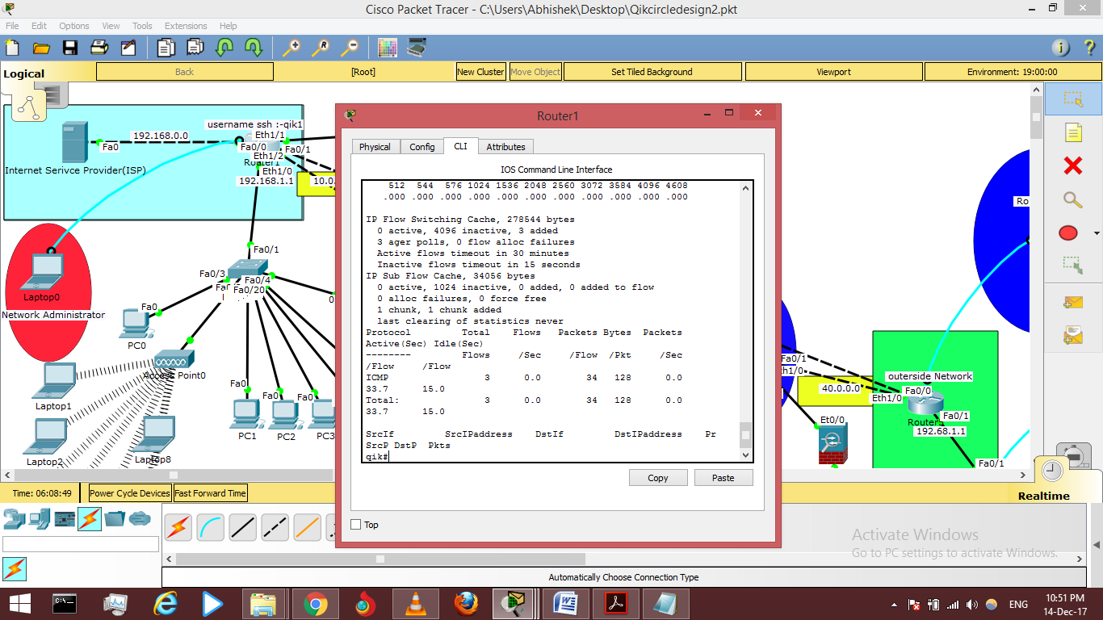

FIG 4.8 Network Monitoring